|  |  |
| --- | --- |
| Date | 09 November 2022 |
| Team id | PNT2022TMID49260 |
| Project name | Hazardous area monitoring area for industrial plant powered by IoT |

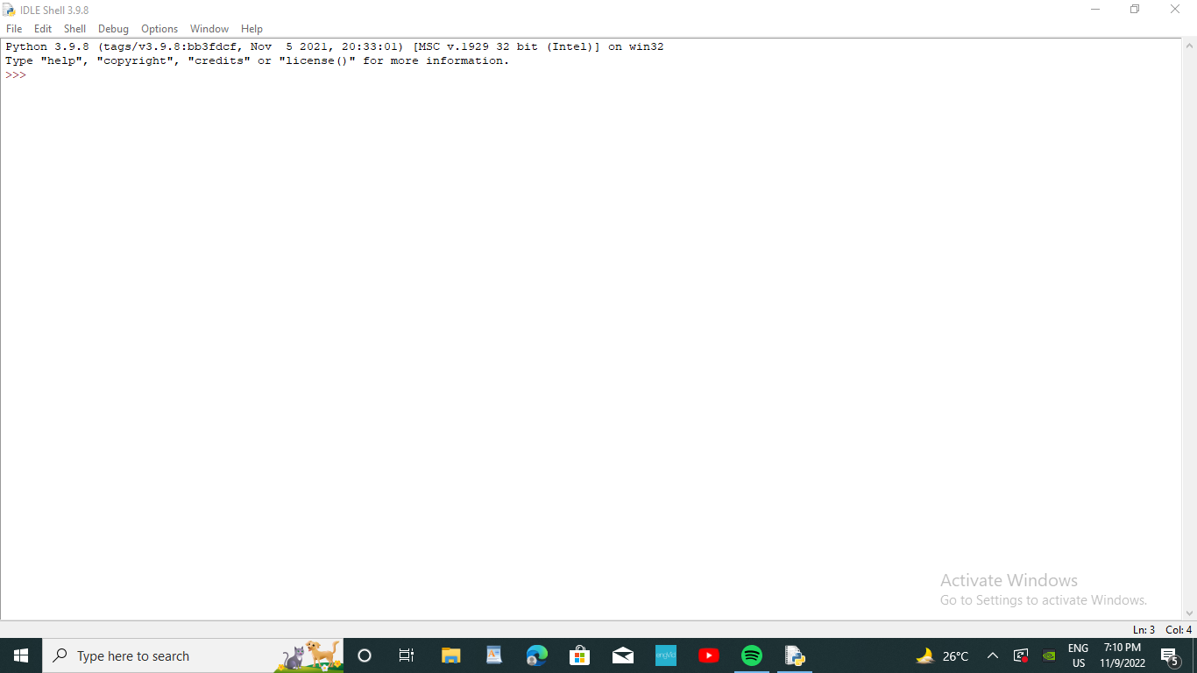

Python Latest version software download successfully